**Assignment 3**

My file rahul.test in hadoop folder



**1.Wordmedian**

Using the below command I’m running the wordmedian program with my file **rahul.test** ,which is in my hadoop folder.And stores the result in output folder

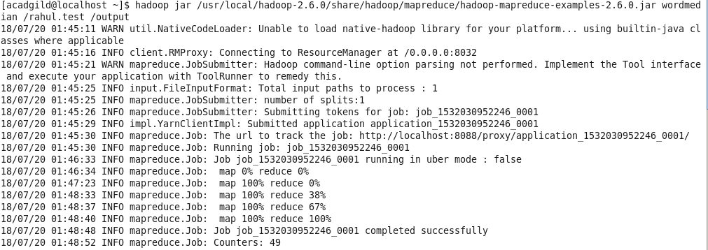

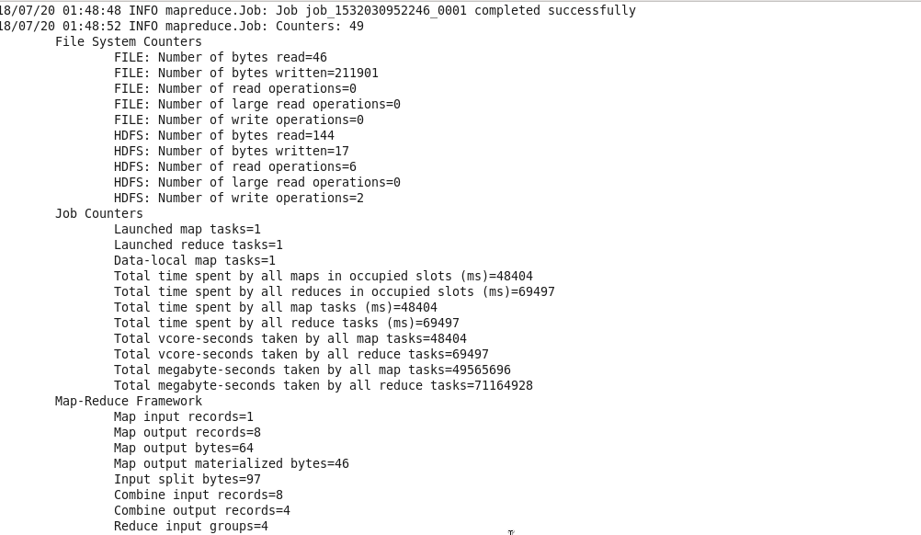

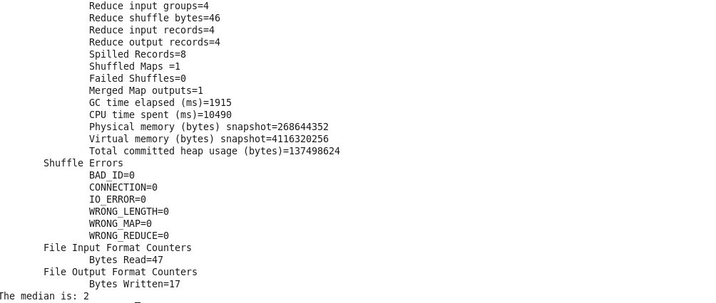

**Entering the below command to see the files in output folder**

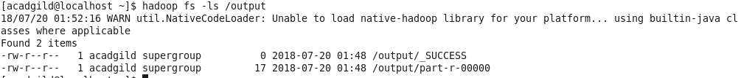

**Opening the file using cat command**

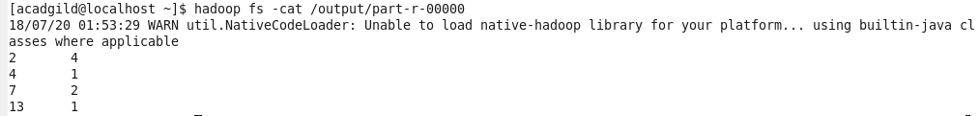

**Removing the output folder. So that I can execute another program using the same.**

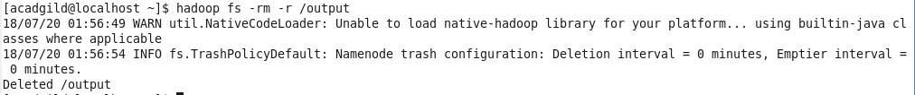

**2.wordmean**

Using the below command I’m running the **wordmean** program with same file **rahul.test** and stores the result in same output folder

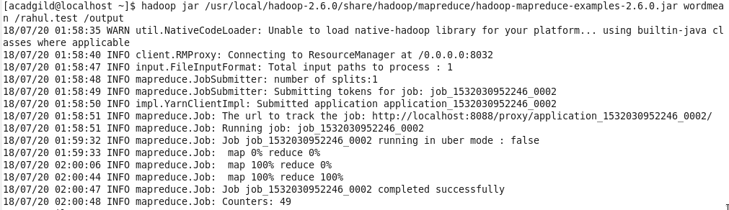

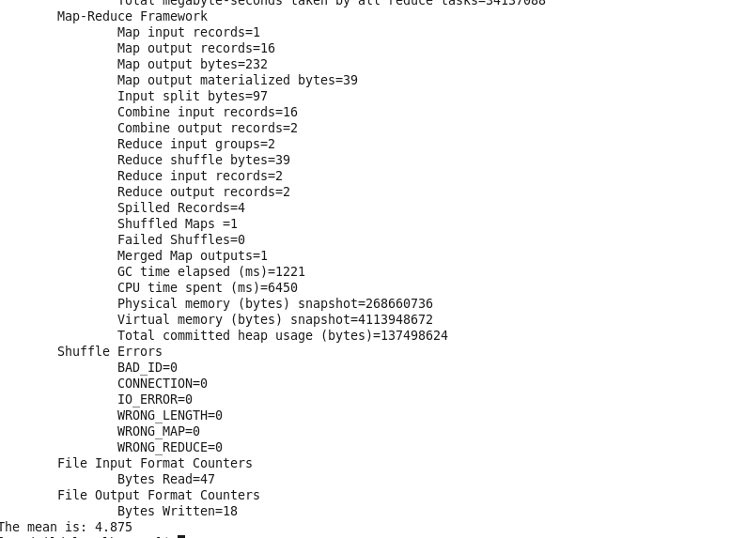

**The output shows the number of words in my file and the number of characters.**



**3.wordstandarddeviation**

Using the below command I’m running the **wordstandarddeviation** program with same file **rahul.test** and stores the result in same output folder

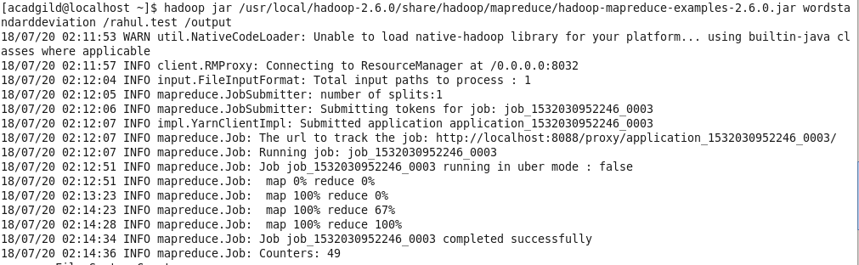



Output:

